What is the impact of unemployment on GDP growth in the United Kingdom from 2001 to 2023? A Quarterly Data Analysis.

Introduction:

The correlation between GDP growth and Unemployment hold sever impact for economic policymaking and understanding the productivity of the economy. The give study provides insights into the complex relationship between the two variables where the data is seasonally adjusted and taken in quarters for a better and more comprehensive analysis.

For the past two decades, United Kingdom has been a witness to fluctuations in both unemployment rates and percentage in GDP growth. This reflects the countries highs and lows admits several economic, social and political changes. In the recent years, the world has been subjected to that of a pandemic. Hence it is urgent to check the reaction and after effects of the said pandemic on the relationship of the variables.

In this study the relationship between GDP growth and unemployment is analysed using linear regression. This is fundamental for understanding the extent of the impact of Unemployment rate on GDP growth. Linear regression allows for quantifying this relationship. This is because it makes it possible to quantify and explain the relationship between unemployment and GDP growth in the UK, linear regression is crucial for answering this research topic.

Researchers can ascertain the direction and degree of this association by calculating the regression equation's coefficients, which can offer important information to stakeholders and policymakers. Furthermore, hypothesis testing is made possible by linear regression, which enables researchers to evaluate the statistical significance of the correlation between GDP growth and unemployment. Furthermore, linear regression can identify significant trends and patterns in the data by modelling intricate interactions and perhaps including non-linear components. This helps us better comprehend the dynamics between these crucial economic variables.

## **Econometric Models**

Linear Regression Model:

In the research paper “The Effect Of Economic Growth In Relation To Unemployment” Misini and Badivuku-Pantina (2017) the relationship between unemployment and normal gross domestic product or nominal GDP from 2004 to 2014 is measured using the data available, secondary in nature from Kosovo Agency of Statistics. The analysis includes descriptive statistics, scatter plot graph analysis and simple linear regression mode. The timeframe in which the relationship is judged is annual by nature. The results have shown to result in a negative correlation between unemployment and GDP growth. The regression analysis confirms showing a 1% increase in nominal GDP is relation with a 0.43% decrease In unemployment rate with the significance being 0. 013.The findings give a sense of understanding of the policies required to implement with this inverse relationship between the variables.

ARIMA MODEL: In the study paper of “Economic Growth Analysis and Forecasting Towards Unemployment Rate” Sahib, Ibrahim (2022) Arima Model was used for the research. The data was collected from the World Development Indicator, World Bank. The variables included were Malaysia’s annual GDP growth and unemployment rate from the years 1961 to 2020 resulting in 59 observations. The Box-Jenkins method was then applied to ensure time series forecasting. This resulted in a inclusion of over 50 observation. The analysis concluded the observation of GPD growth trends in terms of graphical representation. The ARIMA model is a statistical tool using past values to forecast future trends. The parameters applied are (p, d,q) which represent the autoregressive order, difference degree and moving average order respectively. Following this the study made their progress through identification, estimation, diagnostic testing to ensure model accuracy. The diagnostic checking confirmed that the model fit the white noise characteristics of residuals. Forecasting for several combinations of p, d,q, the lag order of (2,1,1) predicted the GDP growth for 2021 to 2026 showing fluctuation in growth rate. Comparisons between the models executed in 2 different software’s confirmed to the robustness of the results. The analysis also revealed the inverse relationship between GDP growth and Unemployment rate which is a direct reference to Okun’s law, indicating how economic problems causes high unemployment rates in Malaysia.

DATA ANALYSIS:

For this study the regression model is used to understand the fundamental relationship between GDP growth and Unemployment Rate.

The variables included are:

* **Control Variable:**

Date: This variable captures the time period of 2001 to 2023, where each year is divided into 4 quarters namely January March July and November.

* **Dependent Variable:**

GDP GROWTH RATE QUATERLY: log value of percentage of growth in GDP accounted for every quarter for the years of 2001 to 2023.

* **Independent Variable:**

Unemployment Rate: Log value of percentage of unemployment rate accounted for every quarter for the years of 2001 to 2023.

The data set includes values from 2001 to 2023 to capture the trend of recent years. Again, the data for the said time period is easily available to be used.

**TIME SERIES PLOT**

Before analysing the variable, it is important to understand trend of the variables. Here the scatter plot has been used for a graphical representation of the variables.

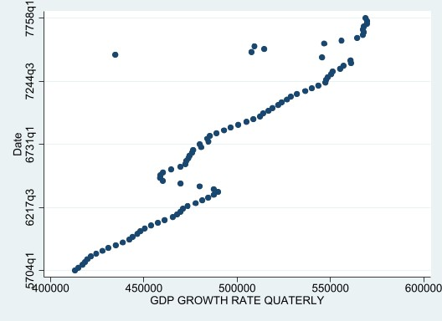

The scatter plot of the above is the representation GDP growth rate per quarter of each year from 2001 to 2023 which reveals sever noteworthy observation. In the beginning it is evident that the increase in the GDP growth rate over time which indicates the economic expansion and recovery. The graph indicates a cyclical pattern, displaying all the periods of economic cycles such as boom recession and recovering. There also is some seasonal variation with GDP growth rates showing period rises and falls, influenced by the policies exhibited in the economy. Overall, the graph shows an upward trend with respect to time.

Top of Form

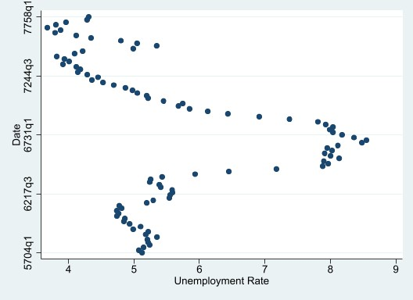

The scatterplot above visualises the correlation between the yearly quarters and unemployment rates. In the previous periods there is a slow increase in the unemployment rate overtime. This could be an indication of economic recession. However, after the peak the rate begins to decrease again could be due to an improvement in employment conditions, The graph displays a cyclical pattern as well. Among the data points some outliers are present. This could be implication of exceptional events and anomalies. Also there appears to be a seasonal variation where the rate exhibits rise and falls periodically influenced by the factors like seasonal industries or hiring factors. Overall the graph provides a visual representation of capturing unemployment rate variation with different cyclical, seasonal factors included.

SUMMARY AND REGRESSION TABLE:





The first table shows the summary of the variables in the study with their own mean and standard deviation, including their range of observation.

Next shows the regression table. The statistical analysis concludes a significant relationship between quarterly GDP growth rate (GDPGROWTHRATEQUATERLY) and the unemployment rate with p-value being 0.000.The coefficient of the unemployment rate variable is -13096.46.This exhibits an inverse proportional relationship between the GDP Growth and Unemployment Rate. This affirms the assumption made by the model chosen by use from econometric regression model. This also confirms the Okun’s law, indicating how economic problems causes high unemployment rates in the United Kingdom. Thus an increase in Unemployment rate will lead to a decrease 0f 13096.46 units in GDP growth. The intercept term(_cons) is the value of 567251.3 represents the estimated GDP growth rate when the value unemployment rate is zero. The R-squared value suggests there is an estimated 0.1666 or 16.66% variability in quarterly growth of GDP explained by unemployment rate. This overall indicates a significance impact of unemployment rate on GDP.

Top of Form

**DIAGNOSTIC TESTS:**

After any analysis it is important to perform some diagnostic tests in order to understand the stability of the model itself. Below some diagnostic tests are performed for better understanding.



Breusch–Pagan/Cook–Weisberg Test (hettest): This test is used to indicate evidence of heteroskedasticity in the residuals or the error term in the model. The chi-square test statistic value is 10.67 and has a p-value of 0. 0011.Thus the null hypothesis of constant variance is rejected.



Cameron & Trivedi's Decomposition of IM-Test (imtest): The test is used to signify heteroskedasticity skewness and kurtosis in the data. Since all the values are significant there can be a presence of heteroskedasticity in data itself.



Ramsey RESET Test (ovtest): Detects the presence of omitted variable bias in the model. Since the F-statistic is significantly larger than the p-value ,the null hypothesis of presence omitted variable bias present in the model can be rejected.



Variance Inflation Factor (VIF) Test (vif): This test indicates the presence of multicollinearity in the data. The value is 1.00 hence this is indication of no multicollinearity among variables.



Breusch–Godfrey LM Test for Autocorrelation (bgodfrey): This test indicates serial autocorrelation among the variables. As the p-value is greater than the chi square test statistic. The null hypothesis of no serial auto correlation is failed to be rejected.

**Conclusion:**

Based on the analysis conducted there is a significant impact of unemployment on GDP growth rate. In the further implication of studies, it can be noted that for a stabilise economy unemployment should always be controlled. The inverse relationship between the variables should suggest that policies implementing the education of unemployment should be considered. This is because a decrease in unemployment can increase to a better GDP according to this study.

For further betterment of this model, the reasons of some diagnostic issues can be checked by using advance techniques. Again, the impact of several types of unemployment’s effect on GDP should also be studied in order to get a better understanding on what factors of labor productivity effect GDP the most.

Bibliography:

* Nuwairah Syazwani Mohamed Ally Jinnah Sahib¹, & Norzuria Ibrahim¹. (2022). Economic Growth Analysis and Forecasting Towards Unemployment Rate Using ARIMA Model. Enhanced Knowledge in Sciences and Technology, 2(1), 47-62. DOI: <https://doi.org/10.30880/ekst.2022.02.01.047>
* Misini, S., & Badivuku-Pantina, M. (2017). The Effect of Economic Growth in Relation to Unemployment. Journal of Economics and Economic Education Research, 18(2), 110. DOI: 10.1533-3604-18-2-110.
* Dataset: Office for National Statistics. (n.d.). Retrieved from <https://www.ons.gov.uk/>